Is this a miracle cancer vaccine? Scientists hail breakthrough treatment as a 'game changer'
- Experts find way of teaching body's immune system to identify cancer cells
- The new medical advance allows patients to be primed to destroy cancers
- In one case, woman given weeks to live cleared of advanced blood cancer
- US patient still alive three years later, and doctors say she is not a one-off

By STEPHEN ADAMS HEALTH CORRESPONDENT FOR THE MAIL ON SUNDAY
PUBLISHED: 22:00 GMT, 21 March 2015 | UPDATED: 12:49 GMT, 22 March 2015

Scientists are having extraordinary success treating cancer with new vaccines they believe could be a ‘game-changer’ in the battle against the disease.
They have worked out how to teach the body’s immune system to identify cancer cells, allowing patients to be primed to destroy cancer.
In one case an American woman given just weeks to live was cleared of advanced blood cancer. She is still alive three years later, and her doctor says she is not a one-off.

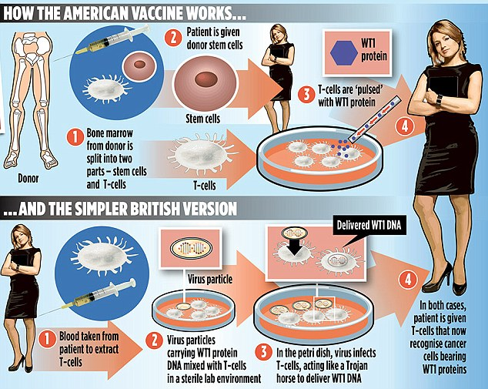
Scientists are having extraordinary success treating cancer with new vaccines they believe could be a ‘game-changer’ in the battle against the disease
British researchers are now working on a related approach.
Both methods involve taking T-cells, which fight infection, and giving them the ability to recognise a special tag on the surface of cancer cells, called the WT1 protein.
The research is being carried out on patients with leukaemia. But the scientists hope their vaccines will eventually be used to fight many types of cancer, including that of breast, bowel and prostate – whose cells tend to have WT1 on their surfaces.
There is even talk of a ‘universal cancer vaccine’ among some scientists, although the researchers themselves believe that is unlikely.

'IDENTIFYING' MARKER ON THE CANCER CELL IS KEY
The treatments aim to help the immune system seek out and destroy cancer cells
They do this by giving T-cells the ability to detect a key marker called WT1
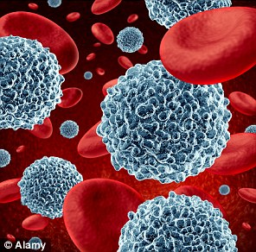
Search and destroy: T-cells can be taught to identify and then kill cancer cells

WT1 is a protein found on the surface of the cells of many types of cancer
T-cells are a type of white blood cell, which fight infections or threats
An infusion of donor stem cells – which can transform into T-cells – may also be used to boost the immune system
Over the past three years, specialist Guenther Koehne, of the Memorial Sloan Kettering Cancer Center in New York, has treated 15 plasma cell leukaemia patients with T-cells taught to recognise cancer.
The disease can be treated with chemotherapy-like drugs but it tends to keep returning. All 15 were expected to die within months given normal treatment. But following his regime, Dr Koehne revealed ‘about half’ were still alive.
He said: ‘I strongly feel this is a game-changer. Before treatment, I talked to these patients and they said to me: “I have no choice, let’s try this.” They had extremely limited life expectancy. A year later, they call me from work and say they are too busy to see me. That’s really happening.’
His treatment involves taking bone marrow from a donor and splitting it into stem cells and T-cells.
The patient receives the stem cells straight away but the T-cells are sensitised to WT1 in the lab by exposing them to fragments of the protein. The T-cells are then given to the patient in a series of injections over several months.
Dr Koehne’s first patient, graphic designer Ruth Lacey, 64, underwent the procedure in 2012 after being so ill following a relapse and intensive chemotherapy that she was ‘comatose’.
But after receiving the stem cells and four T-cell doses, her cancer was reduced to undetectable levels. Dr Koehne said that seeing her ‘in good health and in complete remission’ was ‘clearly an extraordinary experience’.
In the British study, led by Dr Emma Morris – a haematologist at University College London and the Royal Free Hospital, T-cells from up to 20 patients with acute myeloid leukaemia or chronic myeloid leukaemia are to be extracted, inserted with DNA so they recognise WT1, and then put back again.
‘Most people have immune cells which can’t recognise cancer cells, which is one of the major problems with tackling the disease,’ Dr Morris explained. ‘We have genetically engineered patients’ immune cells so they develop receptors for the WT1 protein, making them much better at recognising leukaemia cells.’
One patient has already received an infusion containing genetically engineered’ T-cells and there are others whose cells are being prepared. The DNA is transferred into the T-cells using a ‘dummy’ virus that does not cause an infection. These then provide the blueprint to build the WT1 receptor.

MYELOMA SUFFERER: 'IT'S A WONDER, A MIRACLE THAT I'M STILL HERE...'
Three years ago, Ruth Lacey, was on death’s door having relapsed with an aggressive version of myeloma, a form of blood cancer. She was put in touch with Dr Guenther Koehne at New York’s Memorial Sloan Kettering Cancer Center, who suggested the vaccine.
First, she was given stem cells from her brother Walter’s bone marrow. Next, his T-cells were exposed to WT1 protein. Finally, she received the cells in a series of injections.
At first, recovery was slow. But within two months she began to feel ‘consistently better’ and was allowed home.
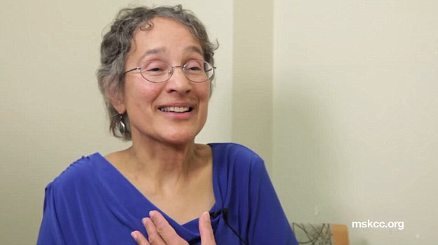
Ruth Lacey was on death's door with a form of blood cancer when a doctor suggested the vaccine

Book designer Mrs Lacey, 64, from Newburyport, Massachusetts, said the treatment meant she was well enough to garden, walk her dog, and go canoeing.
Last summer she did relapse, but she is in remission again thanks to a new drug.
Dr Koehne is also considering another T-cell injection. Ms Lacey said: ‘It’s a wonder, a miracle that I’m still here.’
In the short term, doctors are looking to see if these super-immune cells will be powerful enough to stop leukaemia patients from relapsing after chemotherapy.
But scientists also hope this approach might work to help treat a range of other cancers too.
Dr Morris, whose research with Professor Hans Stauss has been funded by the charity Leukaemia and Lymphoma Research and government body Catapult, said: ‘We could potentially use it in ovarian cancer, breast cancer, and patients with prostate or colon cancer too.’
She said the approach should produce less side effects than chemotherapy and provide longer-term protection than drugs, which are flushed out of the body in days or weeks, because immune cells have a ‘memory’, persisting at low levels in case a threat re-emerges.
The hope is that the genetically engineered T-cells will do this with cancer, said Dr Morris, ‘multiplying again if needed – like an army ready to be reactivated’.
However, Dr Kat Arney of Cancer Research UK, struck a note of caution: ‘These treatments are still in the early stages of clinical trials, and although some people have had great responses, they haven’t worked for everyone.’

